**SELECT with various clause – BETWEEN, IN, Aggregate function**

**AIM:**

To view the records from the tables using SELECT commands with BETWEEN, IN, Aggregate functions.

1.List the type of the courses “Statistics” and “Programming”

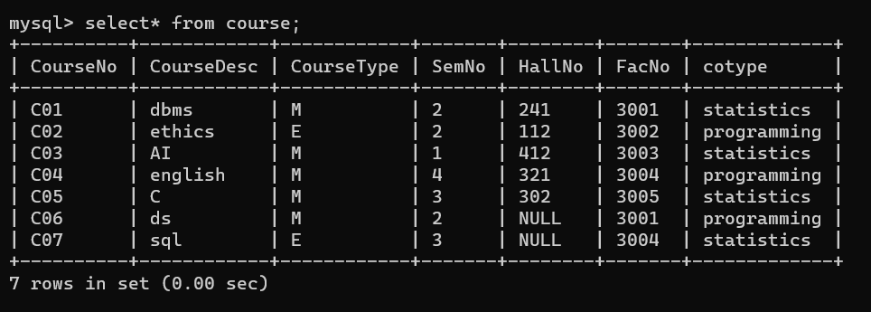

2.The instructor wants to know the Course Nos whose scores are in the range 50

to 80

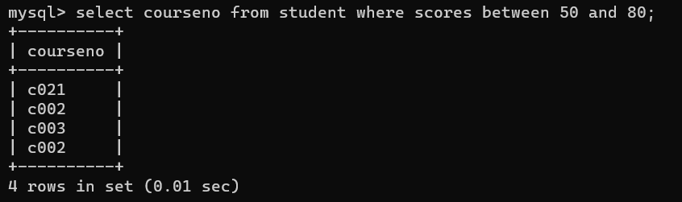

Find the average mark of “C002”.

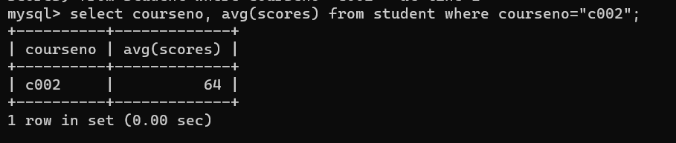

List the maximum, minimum mark for “C021”

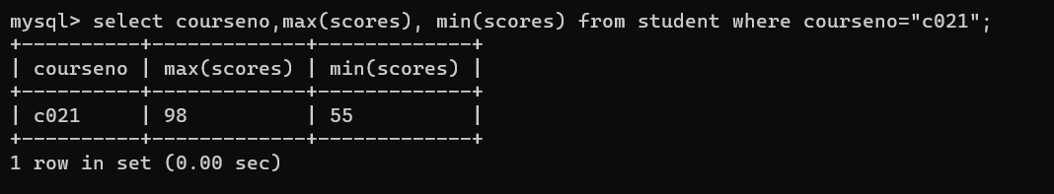

List the maximum, minimum, average mark for each subject in 5th semester

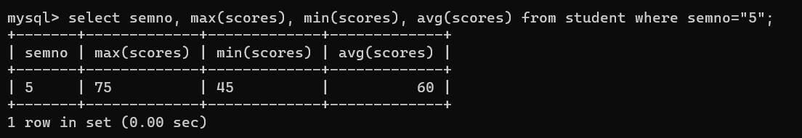

List the name of the courses and average mark of each course.

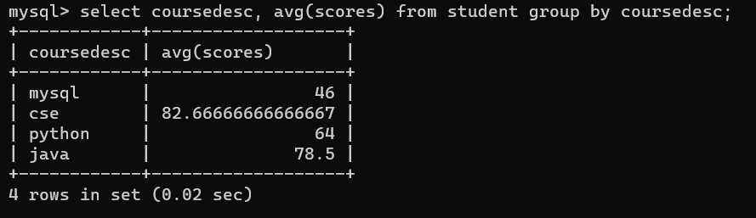

Calculate the sum of all the scores.

mysql> select sum(scores) from student;

+-------------+

| sum(scores) |

+-------------+

| 468 |

+-------------+

1 row in set (0.02 sec)

How many students are registered for each course? Display the

course description and the number of students registered in each course.

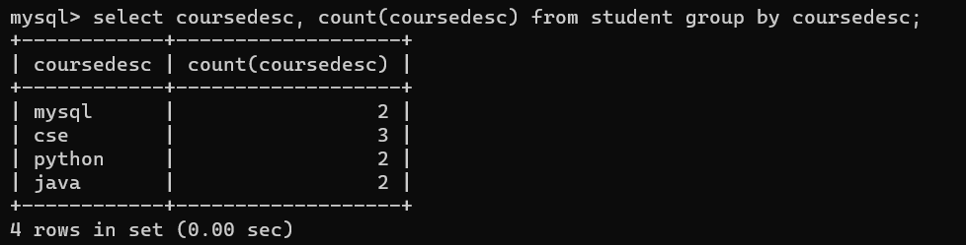

How many courses did each student register for? Use Assessment table.

